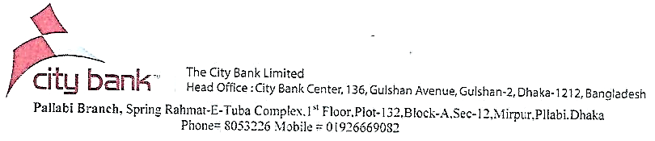

Sequence No.: 191/144/07

The City Bank Limited/Pallabi/2020

Date: 20-11-2020

**TO WHOM IT MAY CONCERN**

This is to certify that **SUSTAINABLE RESEARCH AND CONSULTANCY LIMITED** corporate address of Taz mansion, 28, Kawran Bazar, Dhaka-1215 has been maintaining a Current Account bearing Account No# 00233011965 with our Pallabi Branch since 09-05-2016 and the Conduct of the Account had been Noted Sound & Solvent.

This certificate is issued at the request of our valued client without any risk or prejudice on part of this bank or any official of this bank.



